Development of a Web-Based Smart Store Management System for Retail Store

Yu Yue  
*Institute of Computer Science and Digital Innovation,*  
*UCSI University*Kuala Lumpur, Malaysia  
1001956834@ucsiuniversity.edu.my

Shayla Islam  
*Institute of Computer Science and Digital Innovation,*  
*UCSI University*Kuala Lumpur, Malaysia  
shayla@ucsiuniversity.edu.my

Chloe Thong Chee Ling   
*Institute of Computer Science and Digital Innovation,*  
*UCSI University*Kuala Lumpur, Malaysia  
chloethong@ucsiuniversity.edu.my

*Abstract*—With the continuous development of computer technology and network technology, more and more stores are gradually adopting information management in order to make store operations more efficient, and this project aims to design and develop a web-based intelligent store management system application. By adopting SDLC model as the software development method, meanwhile, a random questionnaire method was conducted to 110 retail store managers or store owners from different countries or regions to determine the user requirements of the system to be developed. A prototype of the system was generated for this project using IntelliJ IDEA Enterprise Edition, MySQL Community Server, and various design software. After the system development was completed, a performance evaluation and user experience survey were conducted to ensure the overall acceptance of the application. The system will help solve the operational management problems of traditional retail stores and help retail store managers to improve the efficiency and performance of managing their stores.

*Keywords—Store Management, SDLC Model, New Retail*

# Introduction

Today, our lives are more and more inseparable from the store, and the store has become a part of our life. Stores are now all over everyone's surroundings. It is a traditional retail business organization that is open 24 hours a day. It not only has the convenience of supply in alleys and small retail stores on the street, but also has the open-shelf sales method and chain management. It has developed very rapidly in the world, especially after using the chain operation method, it has become one of the most organized major formats in the retail industry. Some large chain retail store brands are of considerable magnitude and are well received by consumers like. Among them, there are many retails commercial enterprises operating convenience stores with huge market space and strong market competitiveness, such as 7-Eleven convenience store, Family Mart convenience store, etc. [1].

New retail can maximize the efficiency of the retail industry in the context of the whole society. It is a business model derived from the new era, based on the core of consumers and the form of retailing using data and information technology. In practice, new retail combines the OMO Business Model (Online-Merge-Offline), integrating offline E-Commerce, Shared E-commerce, and Mobile E-commerce into one, meeting the needs of business survival and development and consumer consumption in the context of the new era [2]. The physical access channel is thus optimized, and consumers can enjoy the consumption experience of online, mobile and offline channels, promoting communication between enterprises and users. When enterprises build this complete business platform, they can allocate their resources according to their own product and service characteristics, and develop marketing strategies that can maximize their effects, thus achieving the enhancement of corporate brand image and the expansion of product sales [3].

In this article, an intelligent store management system will be developed, which is based on the Online-Merge-Offline business model and provides solutions for the management of retail enterprises, so that retail enterprises can effectively improve their ability to adapt to the online and offline retail business environment, and help retail Enterprises realize the integration of online and offline business of store and online store, including online store inventory management and online Web application mall, etc., connecting people, goods, and fields, and building a new retail closed loop for chain enterprises. These will be the main points of this article. Questions for research and exploration [2].

# Background

* 1. *Revolution in Retail*

The retail industry has a long history of development. Products produced by any industry need to be delivered to consumers through retailing, such as agriculture, industry, etc. At this stage, the definition of retailing is not clearly defined. There are two mainstream definitions of retail industry, one is from the perspective of marketing, and the other where the U.S. Department of Commerce has given its own interpretation of the retail industry. They consider the industry in which businesses and individuals sell products they buy from distributors to consumers by means of marketing activities. This definition is often seen in the marketing literature, and the definition given by the U.S. Department of Commerce is that any entity responsible for selling only a small number of goods to the masses is retail trade. They only sell but do not produce, and even the services they provide take place in the process of selling goods. The retail trade industry exists in both brick-and-mortar and virtual store models. The retail trade industry is characterized by its direct communication transactions with consumers and the delivery of products and services to them compared to other industries. The number of sales in the retail industry is sporadic and frequent, and the average sales are low. To increase profit margins, the retail industry must control costs and can increase profitability by increasing the variety of products and improving the speed of product turnover. The retail industry faces customers with temporary purchase characteristics, which requires retailers to combine many factors to maximize the attraction of consumers, such as product display, store location, advertising, etc. [3].

By studying the evolution process of the global retail industry, it can be found that: the goal of retail enterprises is to obtain more customer traffic, higher purchase rate and higher customer loyalty at lower cost, and loyalty can lead to higher customer unit price and repeat purchases Rate. People enter the Internet from brick-and-mortar stores, and from the Internet to the mobile Internet [4]. Only with corresponding changes can the business format obtain the most efficient customer traffic.

When the market is in a period when the supply is less than the demand and the communication and logistics infrastructure is not well developed, the retail industry aims to acquire customer traffic at low cost. At the end of the 19th century, productivity was not yet developed, and the retail consumption field pursued a production-driven demand model, because consumer demand grew faster than supply growth, consumers were the receivers of prices, and there were not many choices of goods, and manufacturers did not need to pay attention to consumers, to do too much research. The retail channel is in its infancy, and good retailers have a core principle—find a place where people gather to sell their products [5].

At the beginning of the 20th century, department stores gathered more people at a lower cost. In the process of urbanization, department stores became the places where the growing urban population gathered. Compared with mail order catalogs, the cost and time to obtain customer traffic were shorter, and the efficiency was greatly improved. Gradually replaced mail order catalogs [6]. The way to obtain consumers by mail-order catalogs is to send mail-order catalogs to consumers’ homes by horses. After consumers select them, they will bring back the consumer demand information. The turnaround time is longer, and the transportation cost is also higher. Department stores, on the other hand, can gather a large number of people and obtain more timely information on consumer demand. The increase in demand for information on mail-order catalogs comes at the expense of increased horses, while the increase in foot traffic in a department store is within a range of almost zero marginal cost [7].

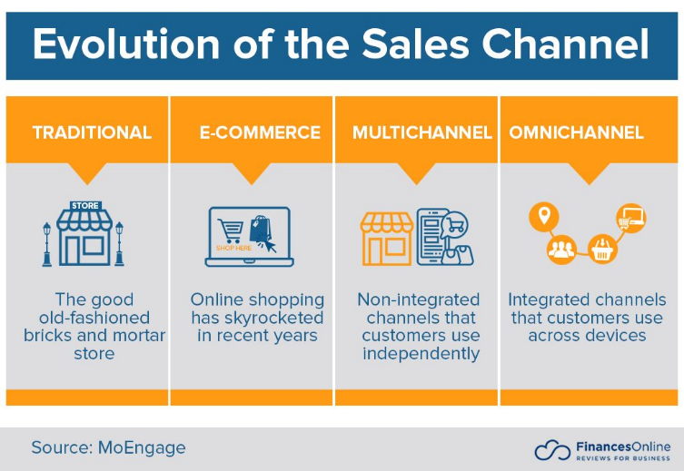

**Fig. 1.** The Evolution of the Sales Channel [8]

With the rapid development of computer networks and information technology, the emerging form of e-tailing has appeared in people's lives, which not only brings convenience to people's lives, but also has a direct impact on the business activities of physical retail. For example, with the establishment of Alibaba in China in 1999, the e-tailing model has continued to influence and change consumer shopping behavior and has won the favor of consumers. The company has attempted to carry out an offline business model with synergistic development of physical retailing and online retailing by establishing an online retailing platform and being enrolled in an e-commerce platform [9]. Through the application of the Internet platform, thus promoting the integration of online and offline, achieving innovative development with Internet circulation and stimulating the vitality of the physical retail industry. The physical retail industry has developed to achieve a combined online and offline model, which improves the efficiency of the industrial chain structure by integrating and utilizing corporate resources in order to meet the survival and development needs of retail enterprises in today's context. However, due to the lack of relevant experience, the physical retail industry still has many problems in the development process, such as unreasonable resource allocation and high costs [10]. Therefore, retail enterprises should fully understand the online and offline retail environment and develop a reasonable marketing model based on this, which is the main problem facing the development of retail enterprises at present.

* 1. *Comparison on existing Applications*

There are many retail business management solutions that already exist on the market, such as iQmetrix whose main business lies in providing IT and services for retail solutions for other businesses, with cloud-based point-of-sale and sales management at its core. Features include mobile POS, maintenance and in-depth reporting and analytics, CRM, marketing and loyalty, advanced inventory management, etc. In addition, RQ involves front-end and back-end succession, including biometric security, marketing automation, payment processing, vendor managed inventory, and more [11].

For Retail Pro, it is a retail management software platform that provides many retail management functions such as KPI reporting, inventory management, customer management, back office, performance statistics, etc. Retailers can use the platform to collect retail data, schedule specific workflows through data analysis, and develop business development plans that align with Retail Pro's benefits. Retailers can extend the functionality of the platform by bringing in third-party solutions such as marketing, ERP, loyalty, and HR systems through the APIs provided by the platform [12].

ChainDrive’s omnichannel retail management solution serves retailers, wholesalers, and e-tailers. Specific industry sectors include department stores, apparel, specialty retailers, footwear, and home furnishings. It helps retailers capture customer data, manage customer relationships, develop effective offers based on customer characteristics, and improve customer retention, with analytics and reporting capabilities to meet users' promotional choices for products. In addition, ChainDrive’s store pre-analysis and calculation functions meet retailers' needs for performance monitoring, store ranking, evaluating store performance levels and charting data [13].

Springboard Retail Platform is about retail management and cloud-hosted point-of-sale. The software provides the business and tools retailers need in all areas and is designed by retailers based on their own development experience and brand development needs. Springboard Retail's intuitive mobile POS provides retailers with additional selling capabilities due to its connection to the Internet. The cloud-based software provides real-time visibility into customer location and shopping behavior, and retailers can collect and analyze this data to develop appropriate sales campaigns to maximize sales. In addition, Springboard Retail offers comprehensive inventory management capabilities that allow retailers to monitor and understand inventory across all sales channels [14]. The table 1 below compares the existing applications mentioned above:

**Table 1.** Comparison Table of existing applications

|  |  |  |  |
| --- | --- | --- | --- |
| **No** | **System Title** | **Advantage Features** | **Bottom Line** |
| 1 | IQmetrix | It uses the latest technology with scalability, ease of use, and security benefits that are well suited for retail management needs and help retailers integrate online and offline resources [11]. | iQmetrix provides integrated POS, retail management and software solutions that help wireless, repair and specialty retailers create an outstanding customer experience [11]. |
| 2 | Retail Pro | It supports up to 18 different languages and multi-currency interfaces, and also supports mining complex data, slicing and sorting data, etc [12]. | Retail Pro is the global leader in retail management software and is known worldwide for its rich functionality, multinational capabilities and unmatched flexibility [12]. |
| 3 | ChainDrive | It is capable of monitoring important data of the store such as store status, sales history, etc. In addition, it can also use sophisticated data mining techniques to query data, pivot and other operations [13]. | ChainDrive is composed entirely of retail process components and is a single-source omnichannel software on which users can base their management activities and implement many operations [13]. |
| 4 | Springboard | It is data-driven, has a level of granularity, has built-in flexibility making it possible to scale up or down seamlessly, plus it can export data to CSV, PDF, or shared URLs [14]. | Springboard's retail management software and retail point-of-sale are integrated with the needs of retailers to provide them with data to support more rational sales strategies to improve profitability [14]. |

# Methodology

In order to achieve the objectives of this study, the methodology used are: 1) To study the currently existing store management systems through literature review, identify the strengths and weaknesses of the existing systems, and gather user requirements; 2) To develop a web-based smart store management system application; 3) To evaluate the performance of the developed web-based smart store management system.

* 1. *User Requirement Gathering*

To obtain user needs, data will be collected through a random questionnaire and the sample will include retail store managers or store owners from different countries or regions. The current status of the application to be developed will be determined by collecting a large amount of information, such as store owners' personal perceptions of existing business management. We invite 110 respondents to fill out the survey, and the data will be analyzed and summarized based on the respondents' responses. The survey will be posted on social media platforms such as Facebook and Twitter, and the questionnaire will be distributed through the Google Forms platform.

* 1. *Design and Development of the System*

The Software Development Life Cycle Model was chosen as the system development method. Software Development Life Cycle (SDLC) is a structured process that helps developers to quickly produce quality software that is properly tested and ready for use [15]. Following the SDLC increases the speed of development and minimizes project risks and costs associated with other production methods. The SDLC model is a linear sequence model consisting of six main phases, namely requirements analysis, system design, implementation, testing, deployment, and maintenance [16, 17].The SDLC is suitable for time-critical projects. The following are the main phases of the selected SDLC waterfall model and are shown in Fig. 2 the sequence.

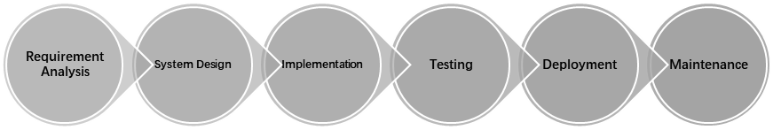

**Fig. 2.** Main Phases of Software Development Life Cycle Model

* 1. *User Acceptance Test*

To evaluate the performance of this retail store management system, a post-development survey will be conducted which will help ensure the overall acceptance rate of the application. A total of 16 users will be invited to take part in a user experience survey. The questionnaire will be distributed via Google Forms to each participant who has been using the application for some time, and users will fill out the form based on their experience after testing and using the application to evaluate the usefulness of the system.

# Implementation

* 1. *The System Scope*

Based on the user requirements collected from the random questionnaire, we determined the general functionality of the application to be developed and used this to design a use case diagram of the system to explain the scope of the project, Fig. 3 below shows the use case diagram for the smart store management application.

**Fig. 3.** User Case Diagram for Shop Management System

In this use case diagram, the three actors represent the store admin user, the customer user, and the supplier. The store admin user represents the relevant person in charge of the store, such as the store owner or the core management personnel of the store. The customer users refer to people who come to the store to buy goods or request services, while suppliers are enterprises that provide goods or services to retail organizations.

In the following Table 2, each use case in the use case diagram is described in detail.

**Table 2.** Descriptions of Use Case Diagram

|  |  |
| --- | --- |
| Use Case | Function and Description |
| Query Order Information | Store admin can query the order information submitted by customers. |
| Edit Order Information | The store admin can modify the order information according to the actual situation of the current order. |
| Set up Goods Delivery | If a customer buys a product online, after the store has an order submitted by the customer in the system, the store admin can arrange the delivery of the product. |
| Automatic Warehousing Registration | Store admin can register purchased items. |
| Inquire Purchasing Information | Store admin can query the purchase information of products |
| Query Inventory Information | Store admin can query product inventory information |
| Update Inventory Information | Store admin can modify the information of in-stock items |
| Modify User Information | The store admin can modify the user's information, it can be the user's type, the user's permissions, etc. |
| Query User Information | Store admin can query the information of existing users |
| Add User Information | Store admin can enter information for new users |
| Delete User Information | Store admin can delete an existing user's information |
| View Items | Customers can view the products through the system's product list, which includes the corresponding thumbnails, prices and numerous attributes of each product. |
| Add To Cart | Customers can add multiple items to the shopping cart at the same time and buy in bulk at one time |
| Set Delivery Location | If the customer buys the product online, he needs to set the mailing address of the product, so that the merchant can arrange the delivery of the product |
| Make Payment | After the customer submits the order, they need to pay for the order |

* 1. *User Interface Design*

The user interface is an integral part of the system that connects or communicates between the system and the user. With the interface, users can interact with the system more easily [18]. Here we show the design of the login module, the product management module, and the order management module as an example to show how the interface of the application should be developed and the functions under this module.

**Fig. 4.** User Interface (Login Page)

图形用户界面

**Fig. 5.** User Interface (Product Management Page)

In Fig. 4 the login page of this application is shown, in this page a form will be displayed where the new user has to enter their username and password, the user has to fill in the text fields with the correct username and password, if there is an error message an error message will be displayed. If all the information entered is correct, the user will be able to redirect to the home page of the application. In Fig. 5 the product management page of this application is shown, it shows all the details of the products in the inventory including product id, product image, product name, product category, price, and other details. The administrator can view all the product details and in addition, the administrator can upload new product information or make changes to existing product information by clicking on the Insert and Modify buttons. Once the administrator has uploaded a product, the customer user can see in their view the product that the administrator has just uploaded to the front-end and perform a purchase action.

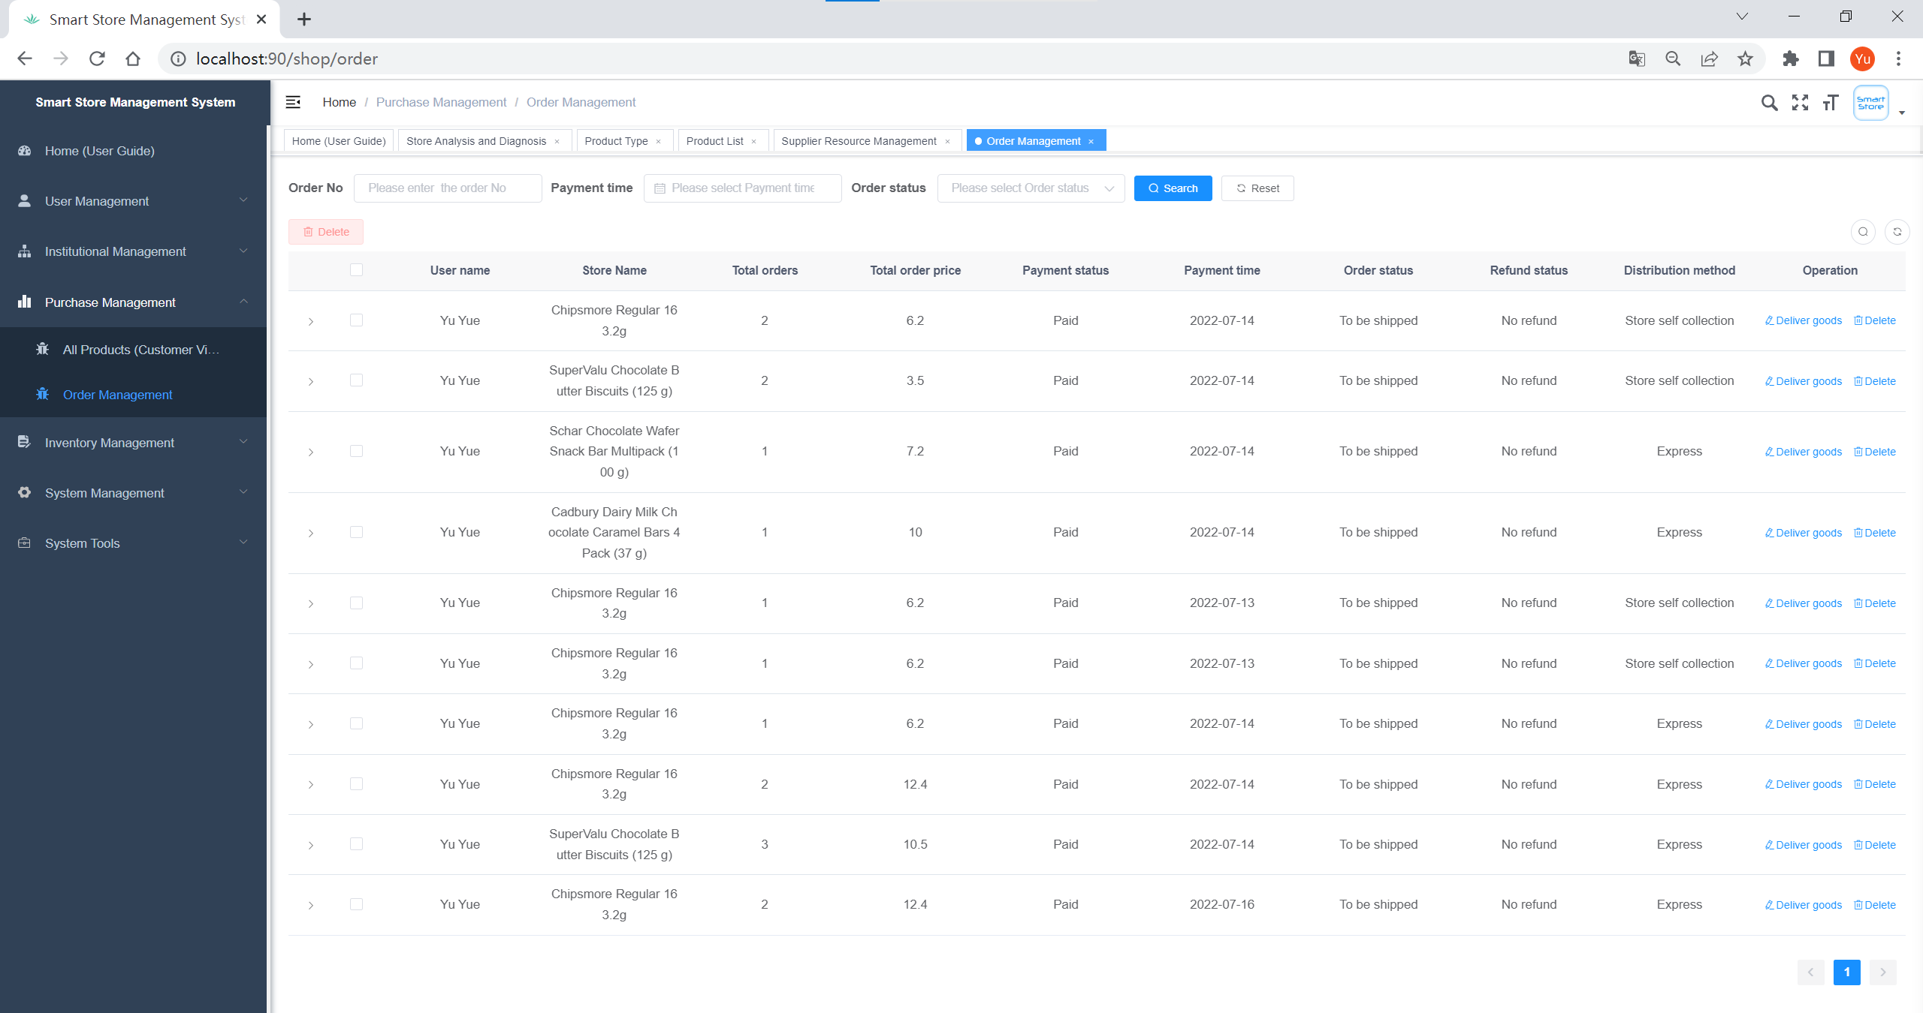

**Fig. 6.** User Interface (Order Management Page)

The order management page of this application is shown in Fig. 6, which manages the orders submitted by the customers. When a customer user performs a purchase operation in the store, the order is automatically created, and at that time the administrator can look up the information about the purchase that the customer just made under this order management module. In addition, the administrator can filter the order information according to some conditions, such as order number, order payment time, order status. When an order is created, the administrator can also perform shipping operations on the order. There are two shipping methods, one is store pickup, and the other is express delivery. In addition, if the buyer has a problem with the purchased product and request to return it, they can request a refund from the seller and then the refund information will be displayed in that order management interface and the administrator can view the refund information and status under this order.

# Results and Findings

In order to evaluate the performance of the system, a post-development survey was conducted and a total of 16 users were invited to participate in the user evaluation. Table 3 below shows the results of the user acceptance test, which was conducted to determine the level of satisfaction with the Web-based smart store management system. Users were required to select the option that best describes their opinion on the statement based on a linear scale, where ‘1’ indicates Strongly Disagree, ‘2’ indicates Disagree, ‘3’ indicates Neutral, ‘4’ indicates Agree, and ‘5’ indicates Strongly Agree.

**Table 3.** Overall User Evaluation Results

|  |  |  |  |  |  |
| --- | --- | --- | --- | --- | --- |
| Statement | 1 | 2 | 3 | 4 | 5 |
| I find it useful to manage product inventory information through this store management application |  |  |  |  | 100% |
| With this Smart Store management system, I can manage my stores more effectively |  |  |  |  | 100% |
| Smart Store has added online channels to sell products, opening up new markets and customers for me |  |  |  | 6.2% | 93.8% |
| The good user interface motivates me to use this Smart Store management application |  |  |  | 6.2% | 93.8% |
| Using this store management application to manage the store is stress-free and it allows me to manage the store more easily |  |  |  | 6.2% | 93.8% |
| I don't need a lot of technical knowledge to use this Smart Store management application |  |  |  |  | 100% |
| Using this Smart Store application can reduce the capital cost and labor cost of my store |  |  |  | 6.2% | 93.8% |
| Smart Store gives me a very good experience of using it |  |  |  |  | 100% |
| I find it very convenient and easy to manage the store through this store management application |  |  |  |  | 100% |
| With this store management application, I can quickly and easily know the status of my store |  |  |  |  | 100% |

Based on this survey, we can conclude that most store managers are very satisfied with this proposed application to manage stores, through this store management application to help them achieve effective management of store order information, purchase information, inventory information and user information, etc. This is in line with the aim of this project, “Develop a web-based intelligent store management system to help retail store managers to improve management efficiency and performance,” and the survey results also showed that it improved the overall experience of store managers when performing browsing and management operations through a good user interface, helping them to manage their stores more easily. In addition, the survey results also showed that Smart Store helped retail store managers to be able to sell their products through online channels by adding channels to sell products online, and it made the retail store's sales channels less homogeneous, solving the problem of the limited number of customers that traditional retail stores can reach. Finally, after comparing each of the objectives of this project and each of the results achieved, it can be concluded that all the objectives of this project have been successfully achieved, the system has been successfully developed and it meets the overall user experience.

# Conclusion and recommendation

* 1. *Conclusion and Contribution*

In conclusion, it can be said that the system has been developed throughout the various phases of the project, making it effective in establishing and achieving the main goals of the project. The main objective was to develop a web-based intelligent store management system application that would enable store managers to achieve effective management of their stores. For the proposed application has been implemented in a web-based platform and is compatible with Chrome, Microsoft Edge and other major browser applications. Although it is not perfect, it has successfully met all the objectives and improved the user experience according to the feedback from the participants who took part in the user acceptance tests. The proposed application can be further developed and enhanced in the future.

* 1. *Limitation*

The proposed application is not perfect due to some limitations of this study. First is the time constraint, developers can only have limited time to do research and learn the knowledge and skills required to develop a proposed application, this leads to some problems for the developers to implement all the features of the proposed application. Also, due to cost constraints, the project will not be developed on any high specification physical server and the web application developed is using only normal PC as the base server for the application, the website occupies too much CPU and load which will lead to slow opening of the website. In addition, there are some system limitations in the development of the proposed application, namely, the application does not support a multilingual and multi-currency interface, the operation of the application requires a client device connected to the Internet for access, and a browser application with the ability to receive data from the server.

* 1. *Future works*

Although the Smart Store Management System developed in this project has received high satisfaction from many users who use it, it could be improved by developing more features to get better. First, future researchers may continue this research and since the proposed application is a web-based application, it can be improved to be compatible with browsers of cell phones or tablet devices rather than just PC browsers, and by being compatible with devices of various screen sizes, the proposed application will be more attractive to the target users. Second, future researchers may continue this project by developing multilingual and multi-currency interfaces, which will lead to an increase in the number of users using the proposed application in different countries or regions, thus attracting the attention of more potential users. Third, future researchers may continue this research to improve and enhance the process of uploading data in the proposed application and support administrators to batch import data such as employee information, department information, product information, and order information into the system, as well as batch export data as Excel file format to the device for more flexible and convenient visual browsing of store details by users.

##### Acknowledgment

I would like to express my deepest gratitude and appreciation to my first supervisor, Dr. Shayla Islam, for the advice and guidance she provided throughout the development of my project regarding the development of a web-based smart store management system for retail stores. In addition, I am also very grateful to my second marker Dr. Chloe Thong Chee Ling, who provided encouragement and guidance throughout the duration of my project. Without the assistance and guidance of my two project supervisors, I would not have successfully completed the goals of this project on time. With their supervision and support, I was able to overcome the obstacles I encountered while developing the entire project. I also learned several new things during the research process of the project, this includes project management and development which helped me to successfully complete my project.

##### References

1. B. Berman, J. R. Evans, and P. Chatterjee, Retail management: A strategic approach. Pearson Education Limited, 2018.
2. Y. Yin, R. Zhang, H. Gao, and M. J. I. T. o. C. S. S. Xi, "New retail business analysis and modeling: A Taobao case study," vol. 6, no. 5, pp. 1126-1137, 2019.
3. M. Hänninen, S. K. Kwan, L. J. T. I. R. o. R. Mitronen, Distribution, and C. Research, "From the store to omnichannel retail: looking back over three decades of research," vol. 31, no. 1, pp. 1-35, 2021.
4. S. Wang, Y. J. G. Zhang, and Change, "The new retail economy of Shanghai," vol. 36, no. 1, pp. 41-73, 2005.
5. S. Mou, D. J. Robb, and N. J. E. J. o. O. R. DeHoratius, "Retail store operations: Literature review and research directions," vol. 265, no. 2, pp. 399-422, 2018.
6. V. Shankar *et al.*, "How technology is changing retail," vol. 97, no. 1, pp. 13-27, 2021.
7. J. J. A. S. Gregory, "The Internet of Things: revolutionizing the retail industry," pp. 1-8, 2015.
8. Financesonline.com. 2022. What Is Omnichannel Marketing & How's It Different from Multichannel Marketing? - Financesonline.com. Available at: https://financesonline.com/what-is-omnichannel-marketing/
9. N. Wadhawan and A. J. I. J. o. R. R. A. Seth, "Technology Revolutionizing Retail Practices in Digital Era," vol. 2, no. 1, pp. 60-62, 2016.
10. S. J. L. L. T. Luce, "Revolutionizing Retail: Workers, Political Action, and Social Change by Kendra Coulter," vol. 75, no. 1, pp. 265-266, 2015.
11. A. Pulga. (2022). Introducing: iQmetrix Inside Sales. Available: https://www.iqmetrix.com/blog/introducing-iqmetrix-inside-sales/
12. P. RESEARCH. (2022). B2B Reviews, Buying Guides & Best Practices. 2022. Top 7 Retail Management Software in 2022 - Reviews, Features, Pricing, Comparison - PAT RESEARCH: B2B Reviews, Buying Guides & Best Practices. Available: https://www.predictiveanalyticstoday.com/top-retail-management-software/
13. P. RESEARCH. (2022). B2B Reviews, Buying Guides & Best Practices. 2022. ChainDrive in 2022 - Reviews, Features, Pricing, Comparison - PAT RESEARCH: B2B Reviews, Buying Guides & Best Practices. Available: https://www.predictiveanalyticstoday.com/chaindrive/
14. Spring-board.info. (2022). Retail intelligence and shopper analytics. Available at: https://www.spring-board.info/
15. G. Raj, D. Singh, and A. Bansal, "Analysis for security implementation in SDLC," in 2014 5th International Conference-Confluence The Next Generation Information Technology Summit (Confluence), 2014, pp. 221-226: IEEE.
16. "UCSI University Object-Oriented Modeling, 2020. Object-Oriented Modeling Lecture Slide Chapter 2. p.1-24.."
17. S. Balaji, M. S. J. I. J. o. I. T. Murugaiyan, and B. Management, "Waterfall vs. V-Model vs. Agile: A comparative study on SDLC," vol. 2, no. 1, pp. 26-30, 2012.
18. T. Zubkova and L. Tagirova, "Intelligent user interface design of application programs," in Journal of Physics: Conference Series, 2019, vol. 1278, no. 1, p. 012026: IOP Publishing.